Dunbar
Shore and Harbour
Neighbourhood Group
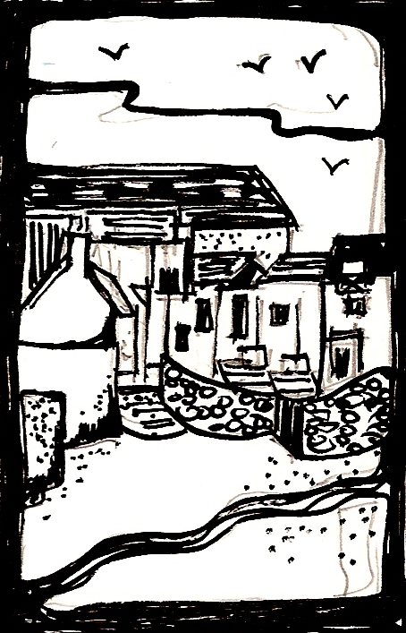

REPORT FOR ANNUAL GENERAL MEETING 2020

Current Committee
Chair Pippa Swan
Vice Chair Mike Shaw
Treasurer Brian Cox
Secretary Colin Barnes and Ian Dane
Tenants’ Rep Tanya Jepson
Member Joan Johnson
Member Alasdair Swan
Member Mark Cavanagh
Member Teresa Barnes
Member Alasdair Swan

Dunbar Shore and Harbour Neighbourhood Group (DSHNG) remains a fully constituted Tenant’s and Resident’s Association and has representation on the East Lothian Tenants’ and Residents’ Panel (ELTRP). We were delighted to welcome Tanya Jepson onto the committee as a tenants’ representative – a long vacant position in our team.

There are some 500 households in our area and membership for 2019/20 stands at 78, which represents a slow but steady increase over the past years.

Our raison d’etre remains. We continue to endeavour to secure improvements to the physical environment of the shore and harbour area and to be good neighbours to those around us.

At our AGM in 2019, we decided to take a break from big projects and to concentrate minds on the small stuff – beach cleans, garden tidies, maintenance of our projects – and to the big issues associated with the East Beach regeneration. We consequently decided to meet as required for projects and to hold a minimum of 2no open meetings per annum, and our constitution was amended accordingly.

The sale of the Methodist Church meant a move of venue (which was sorely felt by many) and we now convene at McArthur’s Store at Cromwell Harbour where we enjoy the use of the public boardroom. Meetings have been well attended and we have a strong core group that contributes in person. Meeting minutes (so carefully compiled by Ian Dane and Colin Barnes) and notices of local interest are emailed to all members, a good number of whom make valuable contributions by mail.

Our principal focus this year has been –

EAST BEACH REGENERATION – Coastal defences and beach improvements
Project value: £0.3m circa
Team: DSHNG East Beach Regeneration team led by Pippa Swan to support ELC
Working with Consultants RHDHV
Project: Regeneration of the East Beach to create an attractive asset for residents and visitors alike.
Comment: The team has met regularly over the year and has been actively supported by Councillor Norman Hampshire. Following public consultation the project looks ready to fly and we hope to see 2no new breakwaters and a new biowall groyne constructed in the first half of 2020.
Natural migration of sand onto the beach in the six months since June 2019 has made a big difference to the shore and it is hoped that the civils work will enhance this.

DSHNG will continue to be key players in this and will play an important role as liaison between ELC/Contractors and the neighbourhood.

EAST BEACH KELP MANAGEMENT – Contractor management for kelp removal
Project value: £20k plus
Team: Pippa Swan with Mike Shaw
Project: Management of kelp to contain fly and smell nuisance.
Comment: This has not been fully activated through the year as it was anticipated that civils work would start in the autumn of 2019. Consequently flies, sandhoppers and rove beetles were all an issue in local homes for the last three months of the year and into 2020. We did, however, have several on site clearances and two major off site clearances.
Thanks again go to AG Thomson for being endlessly inventive and helpful on the occasions when they were called to assist.

EAST BEACH CLEANS – Monthly beach cleans in summer
Project value: Priceless
Team: Mike Shaw with Pippa and Alasdair Swan, Kenny Maule and others
Project: To litter pick the beach on a regular basis
Comment: This has again been solely managed and promoted by Susan Mowatt and we are so grateful to her for doing this.
DofE students opted to litter pick on Sundays over the autumn, which was also hugely encouraging.

BEACH GARDEN + VENNEL PATH GARDEN
Project value: not known
Team: ELC Landscape and Countryside
Project: To maintain the garden ground as a public asset
Comment: ELC took over the maintenance of the garden areas this year. Both areas still require much tender loving care and remain an important link to the beach.

EAST BEACH SEASIDE AWARD
A decision was taken with ELC to remove ourselves from consideration this year as we expected the beach to become a building site. It is hoped that we may be put forward for consideration again in 2020.

CREEL LOADERS GARDEN
Brian Cox has managed the hedges wonderfully and is to be thanked for this.

ESTATE INSPECTIONS
Estate inspections were carried out in late 2019 and a report will be prepared for submission to ELC before May 2020.

In addition to the above, DSHNG members…
- joined with RNLI day (helping Mike Shaw to run the very successful Tombola Stall),
- represented DSHNG at CAPP meetings (Mike Shaw),
- represented TRAs on Area Partnership board
- made representation in respect of development at Coastguard site
- kept East Beach noticeboard refreshed (thanks to Alasdair Swan)

In 2020, our focus will be much as it was for 2019. I very much hope that we find greater support for our facebook page and website, both of which would benefit from more active engagement.

Whilst the same names keep re-appearing in projects, it remains so important that the active participants feel supported by the wider membership and this is happily the case. Feedback, when it comes, is always constructive and generally encouraging.

We always welcome new members and it would be lovely to think that a new cohort might come forward to take the neighbourhood group on into the next decade. Fresh eyes and fresh ideas are always so valuable.

My sincere thanks go to my committee and to all those who have actively engaged with or otherwise supported the work of the project teams over the past twelve months.

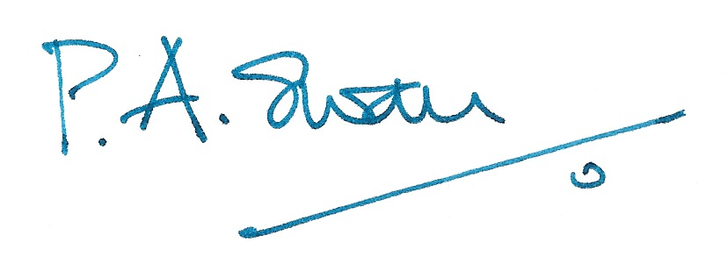

Pippa Swan
Chair
Dunbar Shore and Harbour Neighbourhood Group

4th February 2020

